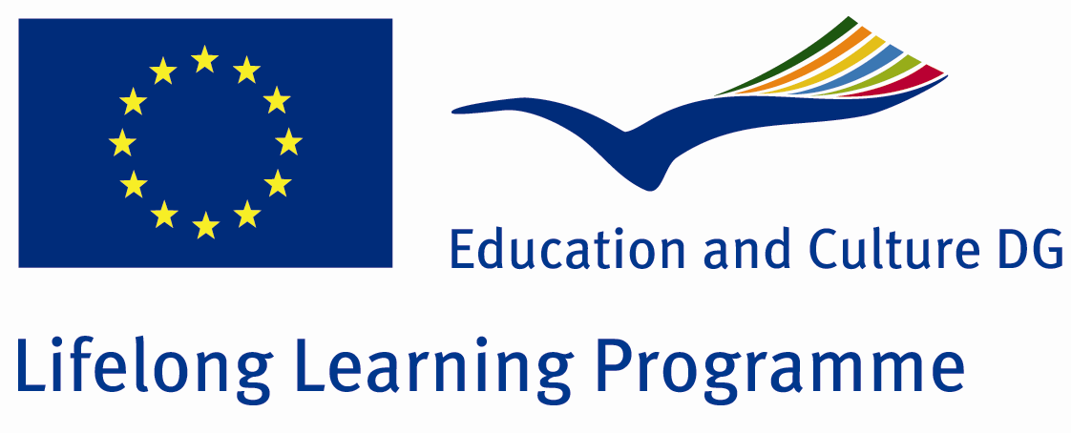 | LEONARDO DA VINCI Programme  PEOPLE IN THE LABOUR MARKET  MOBILITY

Leonardo da Vinci traineeship offer

Host organisation: BEST WESTERN Hotelreservierungs GmbH, Vienna, Austria
BEST WESTERN International is THE WORLD'S LARGEST HOTEL CHAIN® and the hotel industry's largest single brand, providing marketing and reservations to over 4,000 private BEST WESTERN, BEST WESTERN PLUS(TM) and BEST WESTERN PREMIER® (premium class) hotels in 90 countries. Hosting 400,000 guests each night, BEST WESTERN hotels combine international standards with individual flair and heartfelt hospitality.

BEST WESTERN Hotelreservierungs GmbH/BEST WESTERN Central Europe as a regional affiliate and service group attends to over 70 hotels in Austria, the Czech Republic, Slovakia, Hungary, Slovenia, Croatia, Serbia, Montenegro and Macedonia.

Local and temporal specification of the traineeship:
Division/Department: Sales, Marketing, Member Service, Acquisition, Vienna, Austria
Starting date (earliest possible): position open continuously
Starting date (latest possible):
Duration: 5 – 6 months
Working hours: 40/week

Training content (activities/tasks):
- General familiarisation training – collateral, manuals, systems, organisation structure, marketing & sales programmes
- Data search on tourism and economy of all nine countries for annual business plan
- Research of potential partners for specific target group marketing in CEE countries
- Press work – update of PR database via phone calls, translation of press releases
- Member acquisition follow-up – contacting potential members and explaining the advantages of Best Western Membership
- Graphic layout according to BI standards of acquisition brochure in Czech and Slovak language
- Update and translation of Front Office & Electronic Distribution Manual for hotel employees
- Tele-Sales – update of customer database via phone-calls, evaluation of potential, offer of corporate contracts incl. follow-up
- Control, update and improvement of hotel website in three languages in cooperation with hotels´ management
- Research of various key word options for all 74 hotels for Search Engine optimisation
- Reservation system control – Control of hotels´ rate parity on various booking platforms via meta search engines

Required profile of the candidates:
- University graduates in Hotel-&/Tourism Management, (Applied) Economics or Leisure Studies
- Skills within hotel & tourism industry
- Good command of German (verbal and written)
- English desired – not required
- Computer literacy (Word, Excel, Power Point, Internet, Email, ..)
Further, applicants must meet the following criteria:
- Graduates of Palacky University in Olomouc, Moravian College Olomouc, Tomas Bata University in Zlin or other higher education institution having its registered office in the Central Moravia region
- Date of graduation: no more than 1,5 year ago
- You have not carried out a Leonardo da Vinci traineeship, mobility of people in the labour market (PLM) yet
- Permanent residence or perspective employment in the region is advantage

Remuneration:
- financial support – 50 EUR/month
- contribution in kind (e.g. accommodation, public transport, meals etc.) – in the value of 50 EUR/month (monthly public transport card)
Note: beside possible financial support and/or contribution in kind provided by the host organisation, the selected candidate shall receive a Leonardo da Vinci grant. The grant shall be allocated in the max. amount of up to a 4-month scholarship (monthly rate being max. 700 EUR).

Please send your application documents (CV and cover letter in German language) to info@edutrain.cz at least two months before the planned start.

