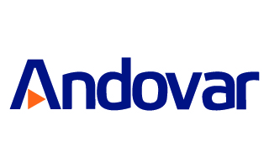
Czech Translators and Machine Translation Post-Editors
(Early career/ EUR 30 per day)

Andovar is seeking a number of early-career translators/students to work on a large machine translation post-editing project for a leading online hotel booking/travel operator. The project is to translate 2 million English words to various languages including Czech. The content is very simple and consists of hotel room names and short booking notes.

This is freelance and work from home position: you must have a reliable internet connection and computer. We can provide successful candidates with the workload that suits your availability. Offer pay is depending on test results.

Requirements:
- Be a native of Czech
- Translation experience is not required
- You must own a recent model computer with an internet connection
- You must be willing to take a short translation/editing test of 400 words

Translator/Editor/Post Editor
- Translators should expect to manage appx 3,000 to 5,000 words per day of straightforward content
- Editors should expect to manage appx 6,000 to 8,000 words per day
- Machine translation post editors should expect to manage appx 10,000 to 15,000 words per day
- Glossary of hotel terminology provided.

Offer pay: up to EUR 30 per day, depending on test results
To apply, please visit http://www.andovar.com/early-career-translators-and-machine-translation-post-editors-required/
Or send email to freelance@andovar.com.

