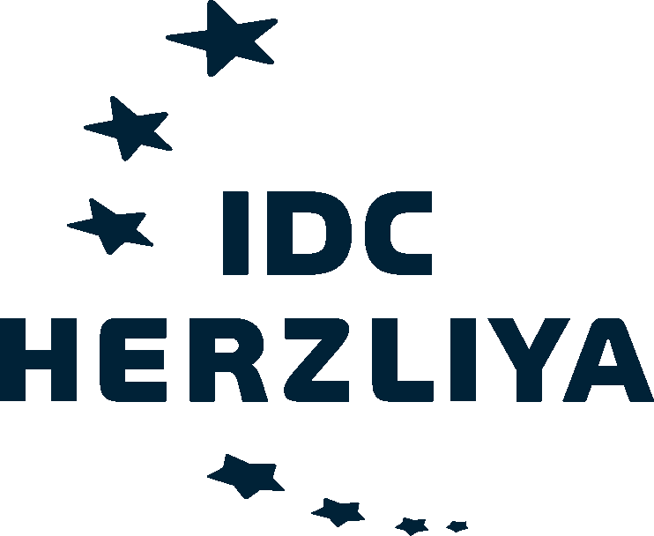
APPLICATION
FOR
MASARYK DISTINGUISHED CHAIR PROGRAM
Call 2014
Deadline: 31 October 2013
- APPLICANT INFORMATION
Title
First name
Family name
Date of birth
Country of citizenship
Private address
Telephone
E-mail

- PROFESSIONAL PROFILE
Home institution in the Czech Republic

Mailing address
Current academic/professional position and starting date in that position
Major academic discipline
Other specialization(s)
Foreign language competence

Most significant professional accomplishments
Include items such as significant teaching and research awards, papers delivered at conferences etc.

Lecturing activity
Summarize your teaching experience and pedagogical approach, indicate your participation in teaching/curriculum projects etc.

Research activity
Summarize your research background and publication activity, indicate your research grants etc.

Professional trips abroad of over 3 months during the past 10 years
Include the country, purpose and length of your stay

- PROJECT DETAILS
Project title
Key words | List 5 keywords that best describe your proposed research activity
Proposed length of stay
(Min. Length = 2 weeks, max. Length = 3 months)
Proposed dates of stay
1st choice:
2nd choice:

Time flexibility | Please state how flexible you are concerning dates of your stay
Lecturing activity at IDC | Are you interested in giving lectures during your stay at IDC? Please specify the relevant subject areas.

Project description
Provide a detailed outline of the research project. Define measurable goals and outputs of your project. Min. 4000 and max. 8000 characters.

- PROJECT IMPACT
Describe the expected impact of the proposed project on your professional competences, including teaching/research activities and benefits for your home and host institution.

- ACADEMIC TUTOR IN ISRAEL
Title
First name
Family name
Instituiton
Position
Telephone
E-mail

- ATTACHMENTS
All applicants are required to submit:
- Curriculum vitae
- Confirmation – either a letter or e-mail from the academic tutor agreeing to support planned academic activity in Israel
- Selected bibliography
- Course outlines or syllabi (in a single combined document, only for projects including lecturing activity – by email only)
- References
All attachments must be provided in English.
- SIGNATURE
I, the undersigned, certify that the information contained in this Application Form is correct to the best of my knowledge.

Place: | Date:
Name: | Signature:

