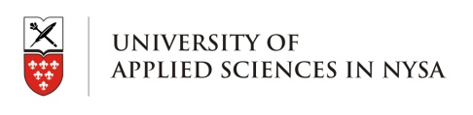
UNIVERSITY OF APPLIED SCIENCES IN NYSA, POLAND

APPLICATION FORM
Summer Polish Language Course for Foreigners 2014

Main course | Yes: | No: | Extra module | Yes: | No:

PERSONAL DATA:
Surname: | Name:
Home address:

Telephone: | Fax: (optional)
E-mail:
Date of birth: | Place of birth:
Sex: | Nationality:
Native language: | Other languages:

EMERGENCY CONTACT:
Surname: | Name:
Home address:

Telephone: | Fax: (optional)
E-mail: | Relationship:

SENDING INSTITUTION:
Name of the Institution:
Address:

Contact person: | E-mail:
Telephone: | Fax: (optional)
Signature of responsible person | Stamp

ACCOMODATION:
Accommodation in students dormitory: | Yes: |  | No:
Arrival date: | Departure date:
I hereby declare my willingness to participate in the Summer Polish Language Course for Foreigners which takes place on 01.09 – 19.09.2014 and that I will pay total amount for the participation.

Please send back the application form by e-mail to the International Cooperation Office (bwm@pwsz.nysa.pl) till 15.08.2014 (handwritten application forms not accepted)

International Cooperation Office
University of Applies Sciences in Nysa
ul. Chodowieckiego 4
48- 300 Nysa, Poland

Signature of the participant………………………

+ 48 77 409 08 56
bwm@pwsz.nysa.pl
www.bwm.pwsz.nysa.pl

